**MODULE 4**

**AUTHENICATION & AUTHORIZATION**

TASK 1 (pp. 1 - 3)

Create a simple Spring Web application with endpoint /study/v1/info with returns simple text:

After added spring security dependency and configuration of web security context:

Endpoint stopped being available without authorization.

After adding authorization header with correspondent data:

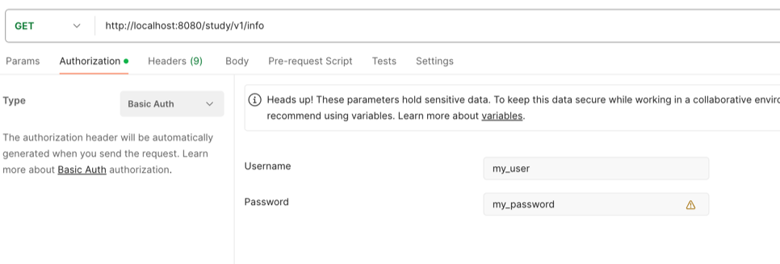

Endpoint started being available back:

TAKS 2 (pp. 4-6)

In-Memory auth does not work anymore:

Havin provided correct credentials we get access to endpoint:

Now let’s try to login under admin user with incorrect password:

And providing correct password we get access to the endpoint under admin user:

BUT, still the password is used as plain text what’s insecure.

Having installed Spring CLI and executed password encode commands:

So, now we can store the password in encoded format as bcrypt. Let’s update Liquibase script to replace password field.

Database table with users looks as follows:

Testing endpoint. With correct credentials for ADMIN user:

With incorrect credentials:

SA user

Admin user:

And with correct credentials for SA user:

Introducing new endpoint /study/v1/about with non-authenticated access:

Trying to call /study/v1/info in non-authenticated mode:

DENIED!

Setting up authentication mode ad providing credentials:

TASK 3 (pp. 7-11)

Arranged endpoints with the following authorizations:

/study/v1/about – non-authenticated mode

/study/v1/info – authenticated mode + requires role VIEW_INFO

/study/v1/admin – authenticated mode + requires role VIEW_ADMIN

The following users are pre-created and stand for verifications:

‘user_view’ has role VIEW_INFO

‘user_admin’ has role VIEW_ADMIN

‘user_view_admin’ has roles VIEW_INFO + VIEW_ADMIN

1. Endpoint ‘about’ does not require authentication:

1. Endpoint ‘info’ requires authentication and role VIEW_INFO:

Users ‘user_view’ and ‘user_view_admin’ can access it:

‘user_view’ accesses:

‘user_admin’ can’t access:

‘user_view_admin’ accesses:

1. Endpoint ‘admin’ requires authentication and role VIEW_INFO:

Users ‘user_admin’ and ‘user_view_admin’ can access it:

‘user_view’ can’t access:

‘user_admin; accesses:

‘user_view_admin’ accesses:

